***Project Name: Number Guessing Game***

1. **Project Introduction**

Guessing games are common, simple and interesting games which can be very effective for teenagers. In Number guessing game, the computer chooses an integer between 1 and 10 randomly. You will continue to guess numbers until you find the number of the computer, and each time the computer tells you the number it chose.

1. **Application Layout**

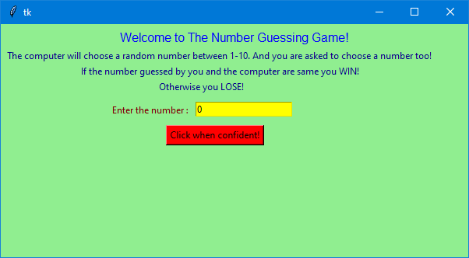

Figure 1: Final Layout of the game

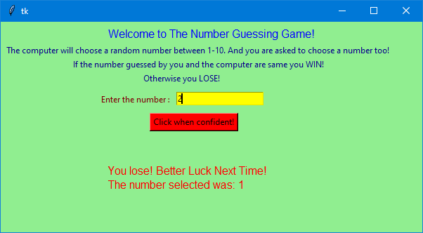

Figure2: Wrong Guess Display



Figure3: When you win

1. Code for the application

The GitHub repository link for the project is: <https://github.com/Isha1504/Number-Guessing-game-using-Python-GUI>